Q4) Write a PROLOG program to calculate the sum of two numbers.

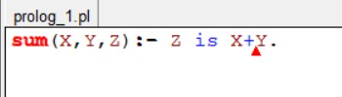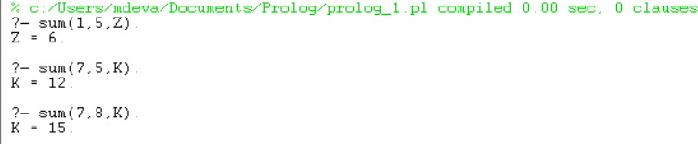

Q5) Write a PROLOG program to implement max(X, Y, M) so that M is the maximum of two numbers X and Y.

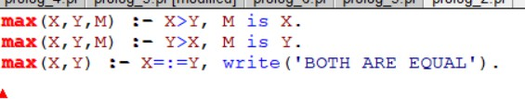

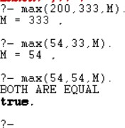

Q6) Write a program in PROLOG to implement factorial (N, F) where F represents the factorial of a number N.

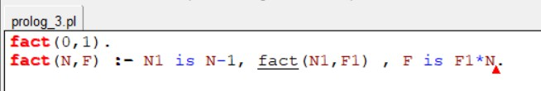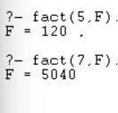

Q7) Write a program in PROLOG to implement generate_fib (N,T) where T represents the Nth term of the Fibonacci series.

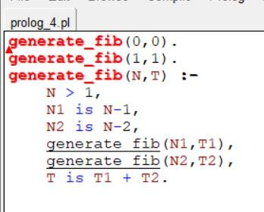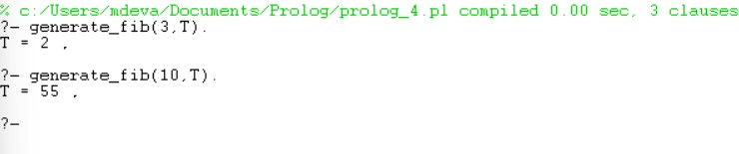

Q8) Write a PROLOG program to implement power (Num, Pow, Ans) : where Num is raised to the power Pow to get Ans.

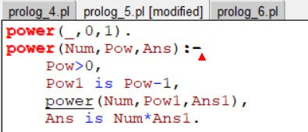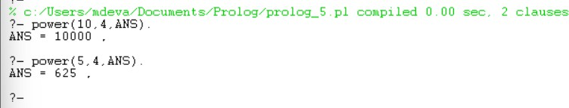

Q9) PROLOG program to implement multi (N1, N2, R) : where N1 and N2 denotes the numbers to be multiplied and R represents the result.

